Advance Excel Assignment 1
- What do you mean by cells in an excel sheet?
- Cells in Excel are small boxes that we see in grid lines ,once you open any excel sheet.
- It is where data are kept. Since data is here, so cell is also a place on which various function/formulas/operators are applied.
- Each cell is unique in terms of its location (which can also be called Reference point).
- Location is made of two parameter the Row number and the Column number, intersection point of these tells the location of a particular cell. It is just like the Cartesians system in (x, y) coordinate to locate a point. Similarly in our case here x (horizontal movement) is column number and y (vertical movement) is row number.
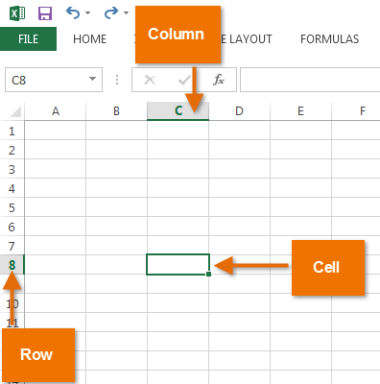

- How can you restrict someone from copying a cell from your worksheet?
There is two ways to do these
- You, hide the formula
- You, lock the cell
But in both the case you have to protect the worksheet by setting a password, how to set password:-
Menu bar >Review > Protect sheet > Password
In the check box you can select either lock the cell/hide the cell
- How to move or copy the worksheet into another workbook?
Fist method (harder):
Steps:
- Open the spreadsheet that you want to copy and also open the workbook where you want to copy.
- Open both spreadsheets.
- Click Move or Copy
- Click on the To book dropdown menu and find the workbook you want this sheet to move to.
- Select the Create a copy checkbox at the bottom of the window.
- Click OK
Second Method (Easier):
Steps:
- Open both spreadsheets but this time side by side
- Click and drag the sheet you want to move to the other workbook.
- Click and hold CTRL before releasing the sheet.

- Which key is used as a shortcut for opening a new window document?

CTRL + N is the combination to open a new window document.
- What are the things that we can notice after opening the Excel interface?

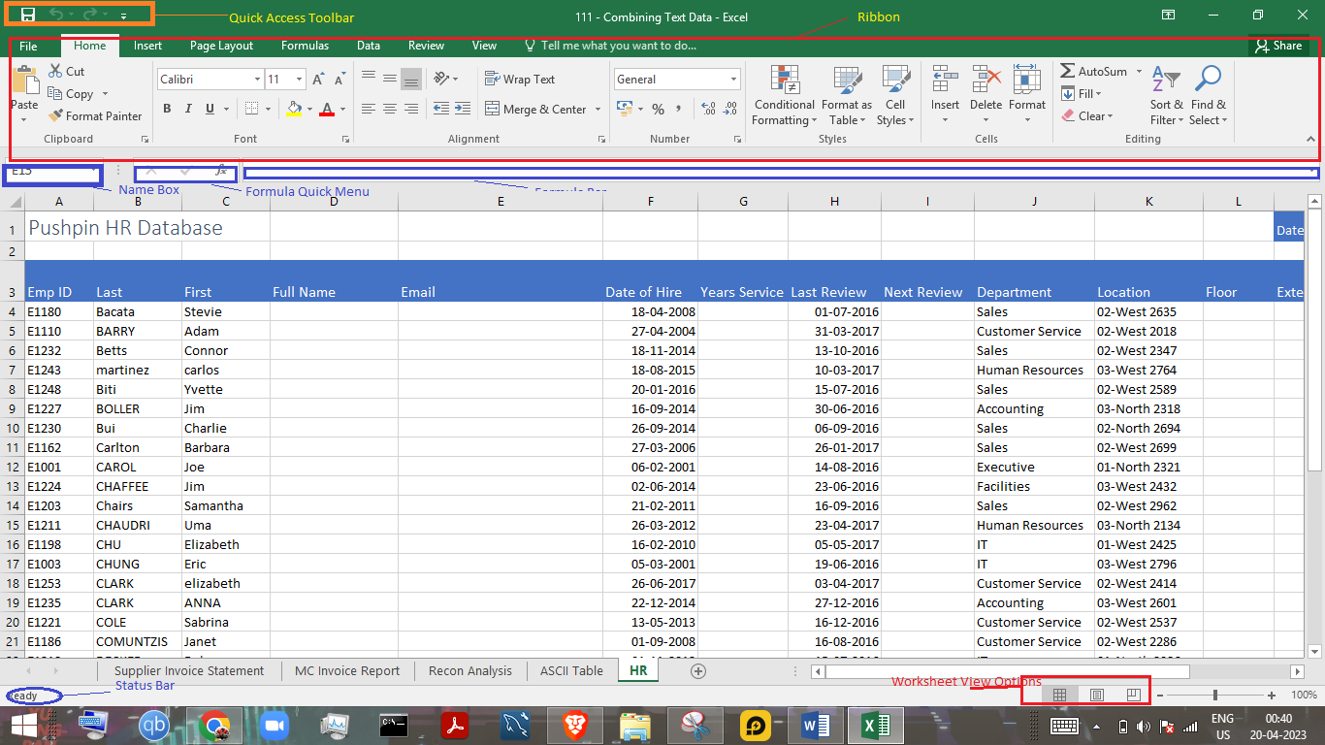
The interface of Excel include the Quick Access Toolbar, Ribbon, Name Box, Formula Quick Menu, Formula Bar, Status Bar, Worksheet View Options, Zoom Slider Control, and the Zoom Percentage Indicator.

- When to use a relative cell reference in excel?
- A formula that contains cell references then if these formula is copied or applied to other cell the cell references is changed accordingly.
- Relative cell reference is by default reference, it use when you are applying for formula/operator to a cell but the formula used for that cell refers to some other cell in order to make calculation complete.

